User Requirements Specification for ICDM (Integrated Chronic Disease Management)

Version 0.1

Programme: SA ICDM

**Document Control**

|  |  |  |  |
| --- | --- | --- | --- |
| **Version** | **Description of Change** | **Author** | **Date** |
| 0.1 | First Draft | Lisa George | 08/03/2016 |
| 0.2 | Added line items that are out of scope form Owen and Pierre feedback (highlighted in orange). Added wireframes for mobile | Lisa George | 8/3/2016 |
|  |  |  |  |
|  |  |  |  |

Table of Contents

1 Introduction 3

**1.1** **Scope** 3

**1.2** **Processes** 4

1.2.1 Highlevel Process 4

1.2.2 Register Patient with possible Chronic Disease 5

1.2.3 Follow up on Confirmation Appointment 7

1.2.4 Document consultation and treatment 9

1.2.5 Follow up on Pharmacy Appointment 14

1.2.6 Review aggregated data (Out of scope for prototype) 16

1.3 Mobile Screens for Prototype 17

1.3.1 Screen 1 Patient Registration 17

1.3.2 Screen 2 Patient Referral case number confirmation 18

1.3.3 Screen 3 Patient Follow up 19

# Introduction

ICSM is a health system strengthening model that builds on the strengths of the HIV programme to deliver integrated care to patients with chronic diseases by taking a patient-centric view that encompasses the full value chain of continuum of care and support.

## **Scope**

The intention of this document is to provide the description of the Prototype required for the ICDM application. The system includes an Android smart phone as well as a Facility DHIS2 solution that is accessed on a laptop.

It covers the requirements identified for the provision of:

* The community Healthcare worker registers Patients that are potentially at risk of chronic disease. The scope of this prototype is limited to Hypertension.
* The Community Healthcare worker follows up on Patients that have not attended their confirmatory appointment.
* The Facility Healthcare worker carries out a patient assessment, diagnosis and documents treatment.
* The Community Healthcare worker follows up on patients that have not attended their Pharmacy follow up appointment at the facility.
* National Department reviews aggregated data for hypertension. (Out of scope for prototype)

## **Processes**

### Highlevel Process

The overview of the process for ICDM

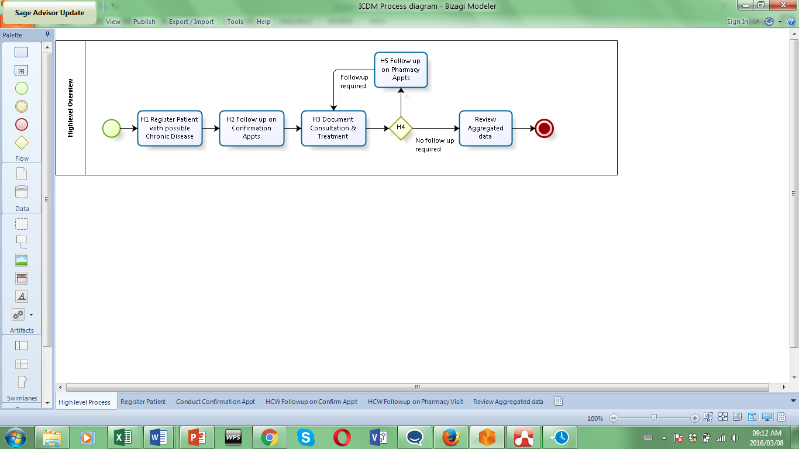

|  |  |  |
| --- | --- | --- |
|  | **Name** | **Description** |
| H1 | Register Patient with possible Chronic Disease | Process of registering patients and the possible Chronic condition for which they require a confirmatory appointment at the Facility |
| H2 | Follow up on Confirmation Appointment | The process whereby the Community Healthcare worker ensures that at risk patients attend confirmatory appointment at the Facility. |
| H3 | Document consultation and treatment | The capturing of data by the Facility healthcare worker. If the patient has a chronic disease, the diagnosis and therapy is documented.  If the patient has one or more Pharmacy follow ups, the therapy is reviewed and further therapy can be prescribed. |
| H4 | Decision point | The process of assessing if a follow up is required. |
| H5 | Follow up on Pharmacy Appointment | The process whereby the Community Healthcare worker ensures that Patients attend their follow up Pharmacy appointments. |
| H6 | Review Aggregated Data | The process whereby National reviews Chronic Disease population statistics using aggregated data. (Out of scope for prototype) |

### Register Patient with possible Chronic Disease

Purpose: Process of registering patients and the possible chronic condition for which they require a confirmatory appointment at the Facility.

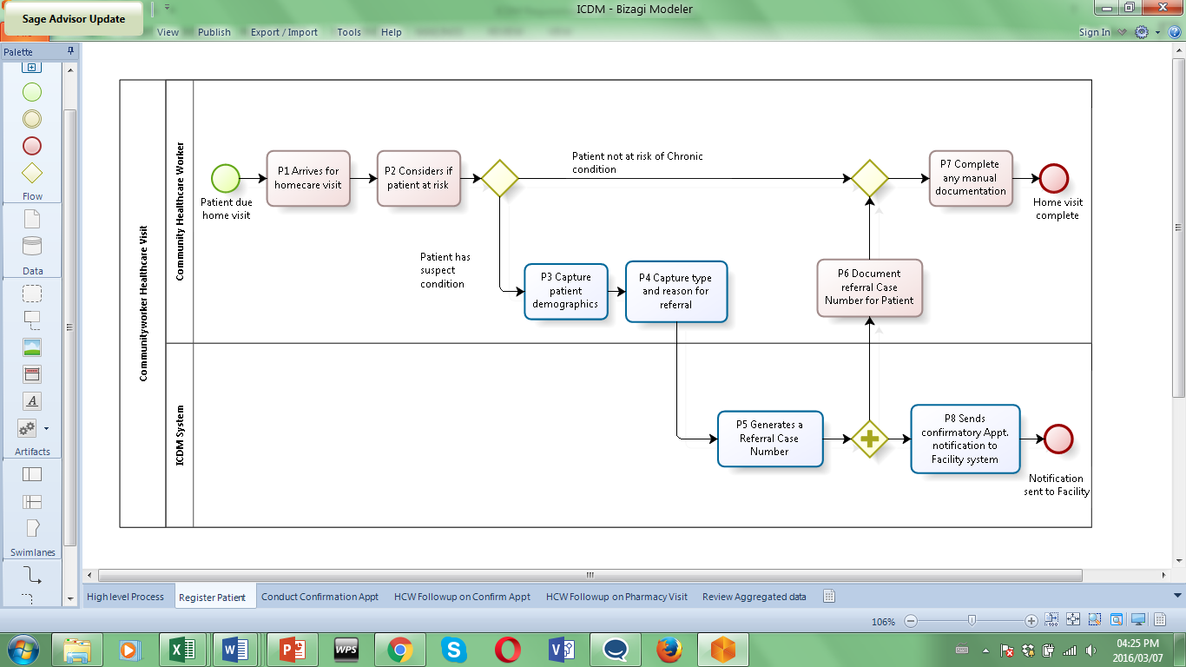

|  |  |
| --- | --- |
| **Reference** | **Description** |
| P1 | *Arrives for homecare visit*  **Actors:** Community Healthcare Worker  **Process type**: Manual  The Community Health care worker carried out routine healthcare rounds in their community. There is no system interaction to trigger the HCW to visit the Patient at this point in the process. |
| P2 | *Consider if Patient at risk:*  **Actors:** Community Healthcare Worker  **Process type**: Manual  The Healthcare worker is trained to assess if the Patient is at risk of a Chronic disease. There is no system interaction to capture any of the findings that flag the Patient as at risk. |
| P3 | *Capture Patient demographics:*  **Actors:** Community Healthcare Worker (CHW)  **Assumptions:** System is up and available, CHW is an existing user.   1. User selects the application. 2. User logs in using a Username and Password. 3. If the User can’t remember details they follow “forgotten access details”   route. (Out of scope for prototype)   1. User presented with the option to register a new patient. 2. The User captures    1. Person First Name,    2. Surname,    3. South African ID number,    4. DOB,    5. Gender    6. Mobile number.    7. User goes to P4. |
| P4 | *Capture Reason for Referral:*  **Actors:** Community Healthcare Worker (CHW)  **Assumptions:** System is up and available, Patient registration details have been entered.   1. User enters a free text reason for the referral i.e. HCW observation of symptoms. 2. User saves Patient details and referral information. 3. System saves Date and Time of referral. 4. User goes to P5 to view referral case number. |
| P5 | *Generate a referral case number:*  **Actors:** Community Healthcare Worker (CHW)  **Assumptions:** System is up and available, ICDM system has generated the referral case number and displayed it to the User.   1. The system generates a unique Referral Case number and displays it on the ICDM screen for review. |
| C6 | *Document the Referral Case Number:*  **Actors:** Community Healthcare Worker (CHW)  **Process type**: Manual   1. The CHW writes the referral number and appointment date on a paper appointment card. |
| P7 | *Complete any manual documentation:*  **Actors:** Community Healthcare Worker (CHW)  **Process type**: Manual   1. The CHW completes any paper documentation that is required as part of the home visit e.g. Vital signs. |
| P8 | *Send confirmation appointment data to the Facility :*  **Actors:** ICDM system  **Assumptions:** System is up and available, System is integrated to the Facility system. The referral number has been generated and triggers this message.   1. When the Referral case number is generated, the ICDM system sends patient and referral data to the Facility system. 2. The ICDM system sends a message with all the patient and referral details:  * Person First Name, * Person Surname, * South African ID number, * DOB, * Gender, * Mobile number, * Referral Case Number, * Reason for Referral * Referral Date |

### Follow up on Confirmation Appointment

**Purpose:** The process whereby the Community Healthcare worker ensures that Patients at risk of Chronic disease attend their confirmatory appointments at the Facility.

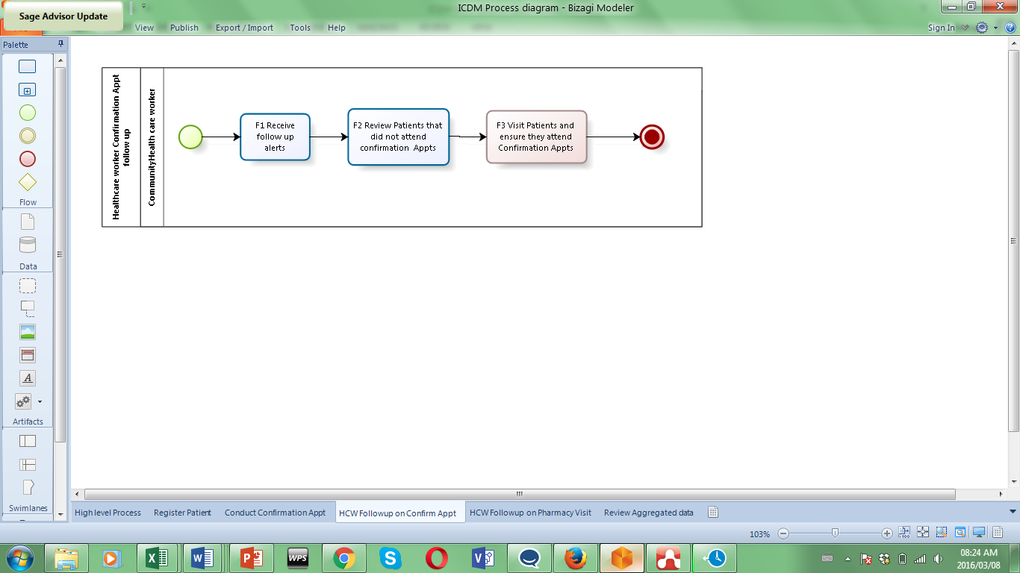

|  |  |
| --- | --- |
| **Reference** | **Description** |
| F1 | *Receive follow up alerts*  **Actors:** Healthcare worker  **Assumptions:** System is up and available, HCW is an existing user.   1. Mobile application display notification from the Facility system for patients that have attended their first confirmatory Appt. |
| F2 | *Review Patients that did not attend confirmatory Appts.*  **Actors:** Healthcare worker  **Assumptions:** System is up and available, HCW is an existing user.   1. User logs in using a Username and Password. 2. If the User can’t remember details they follow “forgotten access details”   route. *(Out of scope for prototype)*   1. User navigates to the ICDM app. 2. User searches for the Patient using an autocomplete return. Only return Patients that were registered by this User. 3. System return matches 4. User selects the required Patient 5. System present the Patient status:    1. Reported Date - this is the date that the Patient attended their confirmation appt. at the facility. Use the date the Diagnosis was captured for Patient.   If the Patient has not attended the confirmatory apt. the only text displayed on screen is ‘Not reported’.   * 1. Diagnosis - Display the diagnosis entered on the Facility system.   2. Therapy - Display the text ‘Medications’ and the entered interval if medication was entered on the facility system.   *(8 and 9 are Out of scope for prototype)*   1. User navigates to and reviews an alphabetical list of Patients by referral Date that have not attended their first Confirmatory Appt. Allow User to filter by district. 2. List details:    1. Person First Name,    2. Person Surname,    3. Gender,    4. Mobile number,    5. Referral Case Number,    6. Referral Date |
| F3 | *Visit patients to ensure they attend their first confirmatory Appt.*  **Actors:** Healthcare worker  **Process: Manual**   1. User visits the patients on the list to ensure they attend the confirmatory Appt. as soon as possible. |

### Document consultation and treatment

**Purpose:** The capturing of data by the Facility healthcare worker. If the patient has a chronic disease, the diagnosis and therapy is documented.

If the patient has one or more Pharmacy follow ups, the therapy is reviewed and further therapy can be prescribed.

The Facility system sends notifications to the Community Healthcare Worker via the ICDM smart phone app to flag which patients have attended the confirmatory appointment and when they are due for the Pharmacy follow up visit.

The Facility system sends messages to the NHIRD system with details of new patients registered for specific Chronic diseases.

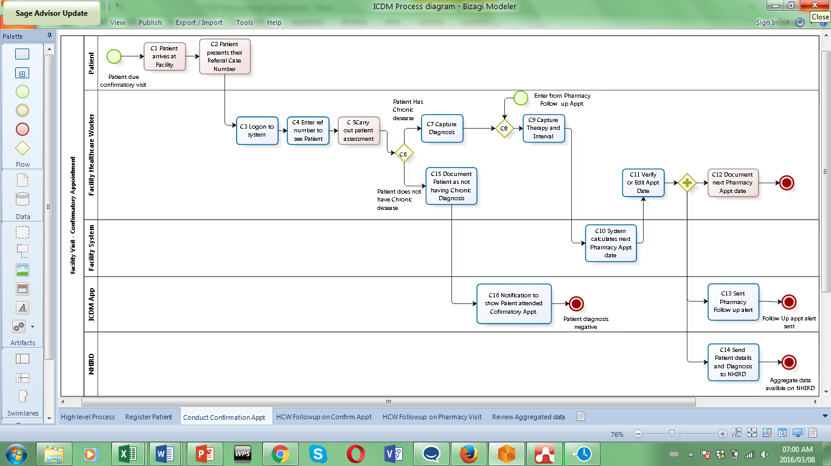

|  |  |
| --- | --- |
| **Reference** | **Description** |
| C1 | *Patient arrives in facility*  **Actors:** Patient  **Process type**: Manual   1. The Patient arrives in the facility for the first appointment to confirm if they have the suspected Chronic disease.. |
| C2 | *Patient presents their Referral case number:*  **Actors:** Patient  **Process type**: Manual   1. The Patient presents their paper appointment card with their Referral Case number. |
| C3 | *Logon to system:*  **Actors:** Facility Healthcare Worker (FHW)  **Assumptions:** System is up and available, FHW is an existing user.   1. User selects the facility application on the laptop. 2. User logs in using a Username and Password. 3. If the User can’t remember details they follow “forgotten access details” route. 4. User navigates to the ICDM module. 5. User is presented with an option to search for or select the Patient. 6. Search for patient    1. User enters the query string into the search box the query string. This is either the patient name or identifier or Referral Case number.    2. User is presented with a list of patients matching the entered search string. The list shows First name       1. Last name       2. ID number       3. DOB       4. Mobile number       5. Referral Case number    3. User identifies patient and selects the patient.    4. User moves to C5. 7. Select patient from Patient due for the first Confirmatory Appt.    1. User is presented with an alphabetical list of patients that have been registered but have not attended their first confirmatory appointment. The list details:       1. First name       2. Last name       3. ID number       4. DOB       5. Mobile number       6. Referral Case number    2. User identifies patient and selects the patient.    3. User moves to C5. 8. Select patient from Patient due for their Pharmacy Follow up Appt.    1. User is presented with an alphabetical list of patients that have been registered and are due a Confirmatory Appointment. The list details:       1. First name       2. Last name       3. ID number       4. DOB       5. Mobile number       6. Referral Case number    2. User identifies patient and selects the patient.    3. User moves to C5. |
| C5 | *Carry out Patient Assessment:*  **Actors:** Facility Healthcare Worker (FHW)  **Process Type:** Manual   1. FHW performs a full assessment of the Patient. 2. There is no system interaction to capture all findings. |
| C6 | *Decision Point:*  **Actors:** Facility Healthcare Worker (FHW)  **Process Type:** Manual   1. The FHW makes a differential diagnosis and determines if the patient is presenting with the suspected chronic disease. |
| C7 | *Capture Diagnosis:*  **Actors:** Facility Healthcare Worker (FHW)  **Assumptions:** System is up and available, Patient has been registered and selected.   1. User selects from a drop down box of available Diagnoses:    1. Anaemia    2. Diabetes    3. Hypertension    4. HIV    5. TB    6. None 2. The User can select one or more. 3. Diagnoses are coded with ICD10 ZA. 4. If the Patient already has a Diagnosis and this is a follow up Appt., the Diagnosis is displayed. 5. User moves to C9. |
| C8 | *Pharmacy Follow up Appointment :*  **Process Type:** An iterative process re-joins this process and User moves to Step C9.   1. If this is a Pharmacy follow up Appt. The existing Diagnosis and Therapies will display to the user. |
| C9 | *Capture Therapy and Interval:*  **Actors:** Facility Healthcare Worker (FHW)  **Assumptions:** System is up and available, Patient has been registered, selected and the Diagnosis has been entered.   1. User enters the query string into the Therapy search box the query string. The User can enter the NAPPI drug description or the NAPPI/ relevant code. 2. If this is a follow up Appt. the existing Therapies will display. 3. User is presented with a list of drugs matching the entered search string. The list shows:    1. NAPPI Description    2. NAPPI Code 4. User identifies and selects one. 5. Therapy is prescribed in the context of a specific Chronic disease. 6. User enters the Interval in days or weeks or months e.g. 1 month. In this example the Patient must return in 1 month to collect their next prescription. 7. If this is a Pharmacy follow up appointment, the interval fields will be empty and the user enters new value. 8. User moves to C11 |
| C10 | *System calculates next Pharmacy Appt Date:*  **Actors**: Facility System  **Assumptions:** System is up and available, user captured Therapy and interval.   1. System calculates the next Pharmacy Appt date = Drug interval – 2 days. If the date falls on a weekend or public holiday, ensure that the Appt is returned as the last working day prior to the weekend or public holiday. 2. Display the Appt. date to the user. |
| C11 | *Verify or Edit Appointment date*  **Actors:** Facility Healthcare Worker (FHW)  **Assumptions:** System is up and available, Pharmacy Appt. date was generated and is visible on mobile device.   1. User reviews Pharmacy Appt date. 2. User can Edit the date using a calendar if required. 3. User saves the diagnosis and therapy details. 4. If this was the first confirmatory consultation, the patient is flagged as attended confirmatory consultation. 5. User moves to C12 |
| C12 | *Document next Pharmacy Appt. date*  **Actors:** Facility Healthcare Worker (FHW)  **Process type**: Manual   1. FHW writes the next Pharmacy Appt. date on the Patients paper Appointment card. 2. There is no system interaction. |
| C13 | *Send Pharmacy follow up alert*  **Actors:** Facility System  **Assumptions:** System is up and available, Pharmacy Appt. date was generated and triggers alert.   1. Facility system send a notification to the ICDM application to show that the Patient has a Pharmacy follow up Appt. 2. Patient flagged as due for Pharmacy follow up appointment as well as the date of next Appt. |
| C14 | *Send Patient details and Diagnosis to NHIRD*  **Actors:** Facility System  **Assumptions:** System is up and available, Patient is Diagnosed with a Chronic disease for the first time.   1. Facility system send a data update to the NHIRD system for all new cases of the new chronic diseases. |
| C15 | *Document Patient as not having a Chronic disease.*  **Actors:** Facility Healthcare Worker (FHW)  **Assumptions:** System is up and available, Patient registered and selected.   1. User selects from a drop down box of available Diagnoses:    1. Anaemia    2. Diabetes    3. Hypertension    4. HIV    5. TB    6. None 2. User select **None.** 3. System does not show therapy and interval and therefore no follow up Appt. required. 4. User saves diagnosis. 5. If this was the first confirmatory consultation, the patient is flagged as attended confirmatory consultation. 6. User logs off. |
| C16 | *Notification that Patient attended Confirmatory Appointment*  **Actors:** Facility System  **Assumptions:** System is up and available, patient Diagnosis saved as None.   1. The Facility system send a notification to the ICDM app to show that the patient did attend the Confirmatory Appt but no chronic disease was diagnosed. |
|  |  |

### Follow up on Pharmacy Appointment

**Purpose:** The process whereby the Community Healthcare worker ensures that Patients attend their follow up Pharmacy appointments to collect Medication.

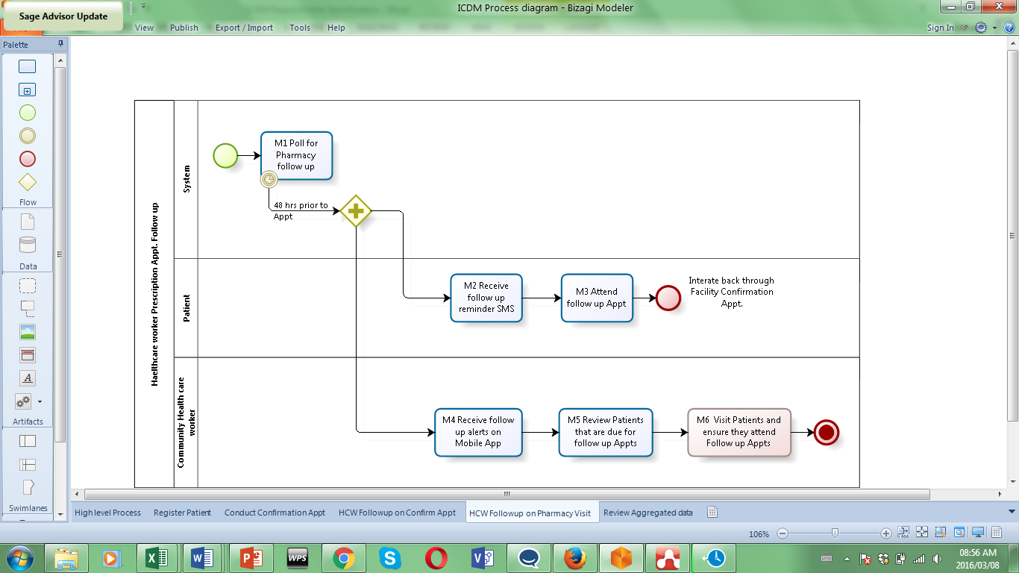

|  |  |
| --- | --- |
| **Reference** | **Description** |
| M1 | *Poll for Pharmacy Follow up Appts.*  **Actors:** System  **Assumption:** System up and running.   1. System polls for Patients that are due a Pharmacy follow up appointment. 2. This occurs on a daily basis. |
| M2 | *Receive Follow Appt SMS*  **Actors:** Patient  **Assumption**: Smart phone up and running.   1. Patient reviews Pharmacy follow up Appt SMS reminder. 2. The SMS reads ‘You are due for a pharmacy follow up appointment. Please visit $Facility$’ to collect your medication. |
| M3 | *Attend follow up Appt.*  **Actors:** Patient  **Process type**: Manual  **Assumption:** Patient received a reminder SMS to attend follow up Appt.   1. Patient attends their pharmacy follow up Appt. at the designated Facility. |
| M4 | *Receive Follow up Alerts on Mobile App*  **Actors:** Community Healthcare Worker (CHW)  **Assumptions:** System is up and available, CHW is an existing user.   1. FHW receives Pharmacy follow up Appt alerts for all Patients that are due a Pharmacy follow up appointment in the next 48 hours. |
| M5 | *Review patients that are due for follow up Appt.*  **Actors:** Community Healthcare Worker (CHW)  **Assumptions:** System is up and available, CHW is an existing user.   1. User selects the application. 2. User logs in using a Username and Password. 3. If the User can’t remember details they follow “forgotten access details” route. *(Out of scope)* 4. User navigates to the ICDM app. 5. User searches for the Patient using an autocomplete return. Only return Patients that were registered by this User. 6. System return matches 7. User selects the required Patient 8. System present the Patient status:    1. Reported Date - this is the date that the Patient attended their confirmation appt. at the facility. Use the date the Diagnosis was captured for Patient.    2. Diagnosis - Display the diagnosis entered on the Facility system.    3. Therapy - Display the text ‘Medications’ and the entered interval if medication was entered on the facility system.   (9 & 10 Out of scope)   1. User navigates to and reviews an alphabetical list of Patients due a Pharmacy follow up. Allow User to filter District and sort by Date 2. List details:    1. Person First Name,    2. Person Surname,    3. Gender,    4. Mobile number,    5. Referral Case Number,    6. Pharmacy Follow up Date |
| M6 | *Visit Patients and ensure they attend follow up Appt.*  **Actor**: Community Healthcare Worker  **Process Type**: Manual   1. Using the list, HCW visits all patients that are due a Pharmacy follow up visit to ensure they collect their medication. |

### Review aggregated data (Out of scope for prototype)

**Process:** The process whereby National reviews all the aggregated data for the Chronic conditions per facility.

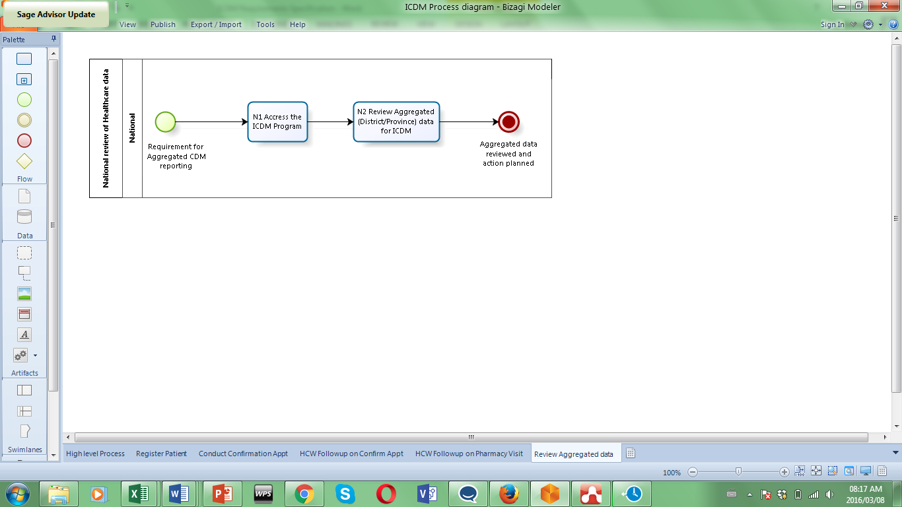

|  |  |
| --- | --- |
| **Reference** | **Description** |
| 1 | *Access ICDM program*  **Actor:** National  **Assumptions:** System is up and available, National worker is an existing user. This is not in scope for proof of concept. Reports to be defined as part of a full system roll out.   1. User selects the application. 2. User logs in using a Username and Password. 3. If the User can’t remember details they follow “forgotten access details” route. 4. User navigates to the ICDM program and the correct Facility. |
| N2 | *Review Aggregated data for ICDM*  **Actor:** National  **Assumptions:** System is up and available, National worker is an existing user. This is not in scope for proof of concept. Reports to be defined as part of a full system roll out. |

## Mobile Screens for Prototype

### Screen 1 Patient Registration

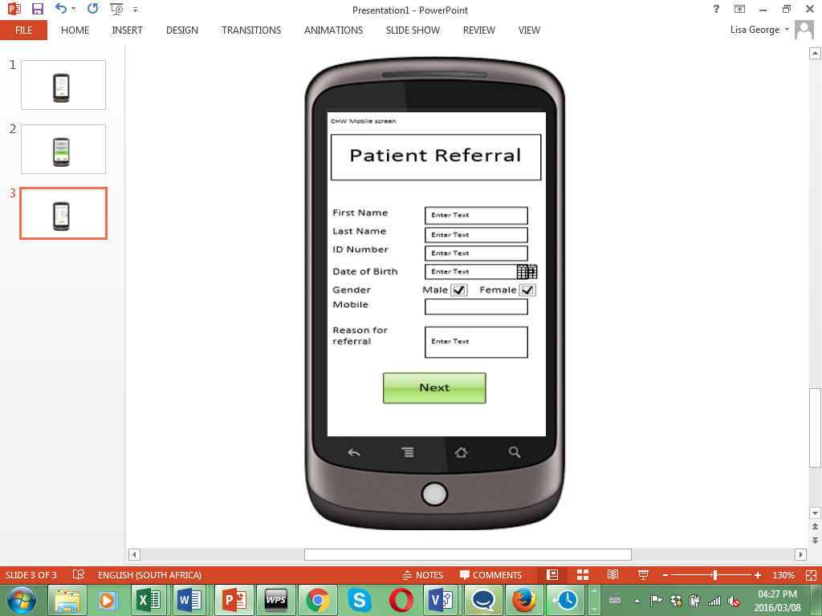

|  |  |  |
| --- | --- | --- |
| **Field Name** | **Type** | **Description** |
| Patient Referral | Header |  |
| First Name | Text box | Input field for Patient First Name |
| Last Name | Text box | Input field for Patient Last Name |
| ID Number | Text box | Input field for Patient ID Number |
| Date of Birth | Date field | Calculate from first 6 digits of ID number OR allow user to type the DOB or enter DOB using calendar control |
| Gender | Tick box | Tick bod for male or female |
| Mobile | Text box | Input field for Patient Mobile number |
| Reason for referral | Text box | Large text box 100 characters  Input field for Reason for referral |
| Next | Button | Save the Patient registration information and generate a Referral case number. Move to Screen 2. |

### Screen 2 Patient Referral case number confirmation

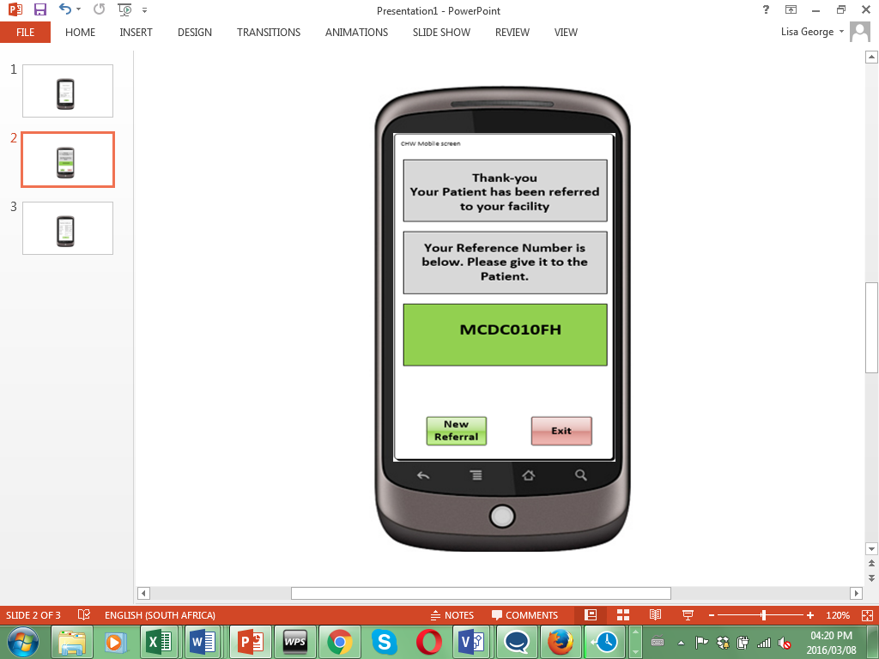

|  |  |  |
| --- | --- | --- |
| **Field Name** | **Type** | **Description** |
| Message text box 1 | Text | Display the following message  Thank-you Your Patient has been referred to your facility |
| Message text box 2 | Text | Your Reference Number is below. {Please give it to the Patient. |
| Referral case number box | Text | Display the auto generated referral case number e.g. MCDC010FH |
| New Referral | Button | Return to Screen 1. Clear all fields for new registration. |
| Exit | Button | Exit application. |

### Screen 3 Patient Follow up

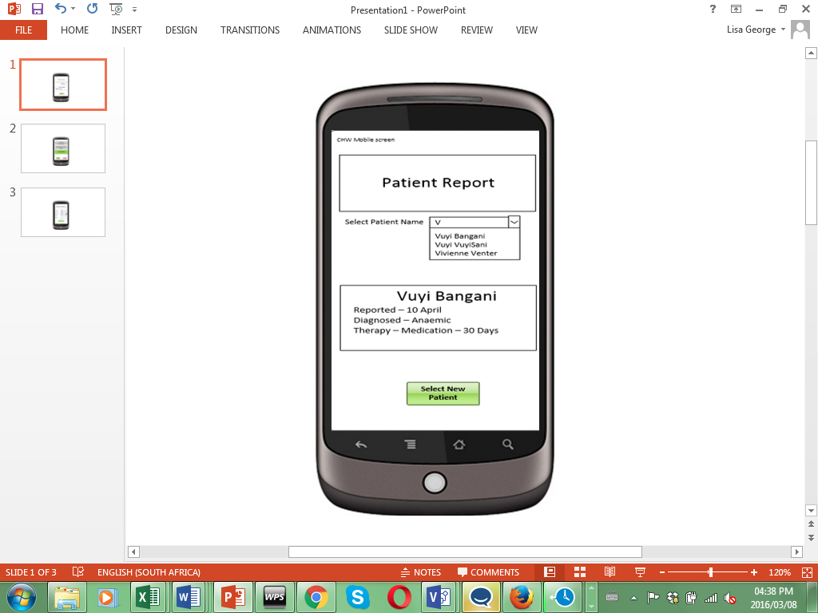

|  |  |  |
| --- | --- | --- |
| **Field Name** | **Type** | **Description** |
| Patient Report | Header |  |
| Select Patient Name | Autocomplete Search field | As soon as user starts typing, return Patient matches for Patients registered by the logged on HCW |
| Patient Name | Text | Display Patient First name and last name |
| Reported | Text | Date the Diagnosis was entered for this Patient i.e. when the patient attended the first confirmatory apt. |
| Diagnosis | Text | The coded Diagnosis description entered on the Facility System for this Patient |
| Therapy | Text | Display the word ‘Medication’ and the interval value entered if therapy was entered on the system. |